Attention: To Whom It May Concern

RE: Confirmation of Participation

________________ (Company Name) will exhibit at Label Summit Latin America 2019, held at Plaza Mayor Medellín on 14 - 15 May 2019, taking stand (Stand Number) __________.
Label Summit Latin America is part of the Labelexpo Global Series of exhibitions that are held internationally in Europe, Asia and the Americas. We have over 1000 exhibitors globally within the label industry who exhibit in these events.

Labelexpo is part of the Tarsus Group, an international events and publishing media business. Please feel free to go to our website for more information.
www.tarsus-group.com

If you have any additional questions, please feel free to contact myself, Jessika Bustamante, at +1 (262) 754 6925 or by email at jbustamante@labelexpo.com.

Sincerely,

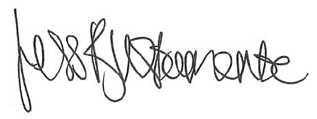

Jessika Bustamante
Event Manager
Label Summit Latin America
www.labelsummit.com/colombia/

Tarsus Group Ltd
Metro Building, 1 Butterwick
London, W6 8DL

